For Further Information
War of 1812 Graveside Project
www.1812Veterans.ca

Special Thanks To
Glenwood Cemetery
Royal Canadian Legion – Mike Slater

War of 1812

Graveside Project

Unveiling Ceremony

William Johnson

1785 – 1852
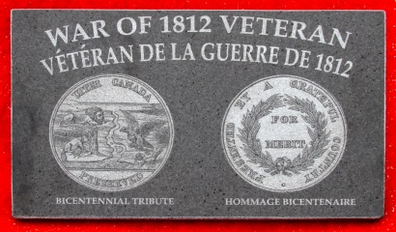

Ceremony Agenda
Welcome – Seaghan Hancocks
About the Graveside Project – Lyn Downer
About William Johnson – Seaghan Hancocks
Salute to Comrade – Royal Canadian Legion
Royal Newfoundland Regiment (1812 re-enactors) – Fire Salute
Closing – Seaghan Hancocks

William Johnson
- Born 23 Dec 1785 to Andrew and Mary (Lawson, Lassen) Johnson in Dutchess County, NY.
- Married 27 Apr 1807 to Abigail Garret (b 14 May 1790 – 23 May 1819) and had four children (James, Sarah, Mary & Hiram)
- Married for a second time on 31 Jul 1820 to Elizabeth Casey (b 8 Sep 1788) and had another four children (William Henry, Abigail, Martha Jane and Margaret Elizabeth) and settled in Lot 24, Conc 2 of the Military Tract, Hallowell twp, Prince Edward County.
- Elizabeth’s father William Casey UE, b 25 Jul 1760 in South Kingston Rhode Island, and son of Samuel Casey, a well known silversmith. William Casey was a Master Carpenter in the Quartermaster General’s Department at Yorktown during the Revolution. One family story says that Elizabeth traded her 200-acre land grant for a wagon, supposed to have been the first one in “The County.” It was used in the family for the next 50 years, and must have been of amazing durability. Perhaps it had been built by her father.
- William Johnson served in the 1st Regiment Prince Edward Militia with Jacob Shortt (his daughter-in-law’s father of William Henry) and according to family stories both Jacob and William were present at the Battle of Queenston Heights when General Sir Isaac Brock was killed.
- The sword used by William Johnson during his war service is still in existence and is owned by one of his grandsons although I’ve been unable to locate it. The fact that he carried a sword implies that he was an NCO or at the very least, in charge of men.

